The office of Institutional Effectiveness (IE) offers a number of interactive reports, which allow the user to sort, drill down, and display the data to best fit their needs. These reports are published using Tableau software. This user guide will cover the basics of Tableau use, and help you start interacting.

**General Information about a Specific Report**

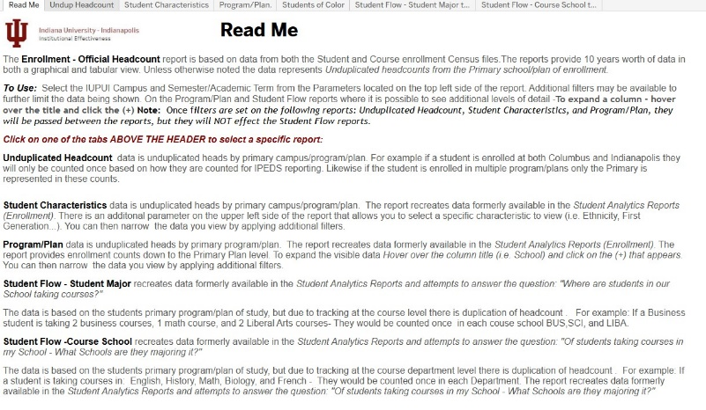 **Read Me** – Many of the Tableau reports include a **Read Me** page that provides an overview of the purpose of the various reports that are included in the various tabs within the report. It may also provide information on where the data is from and when you can expect the reports to be updated.

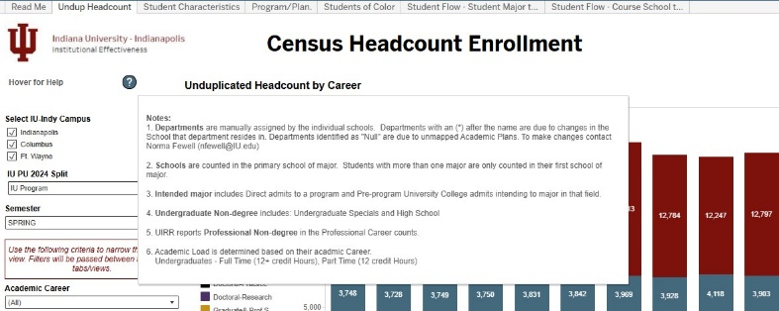

**Hover For Help**  - This icon is usually located in the upper left corner of a Tableau report. When you hover over the Question mark information (definitions, explanations, notations) specific to the given report will be displayed. It will also include the name of the individual to contact for additional help with a specific report.

**Using an Interactive Report: Filters and Functions of a Dashboard**

***Tabs:*** Some reports have different tabs across the top of the screen (above the IE Icon), which contain different views. Be sure to select the tab that best reflects your question. To move to a different sheet, just click on the tab. Here’s an example:

******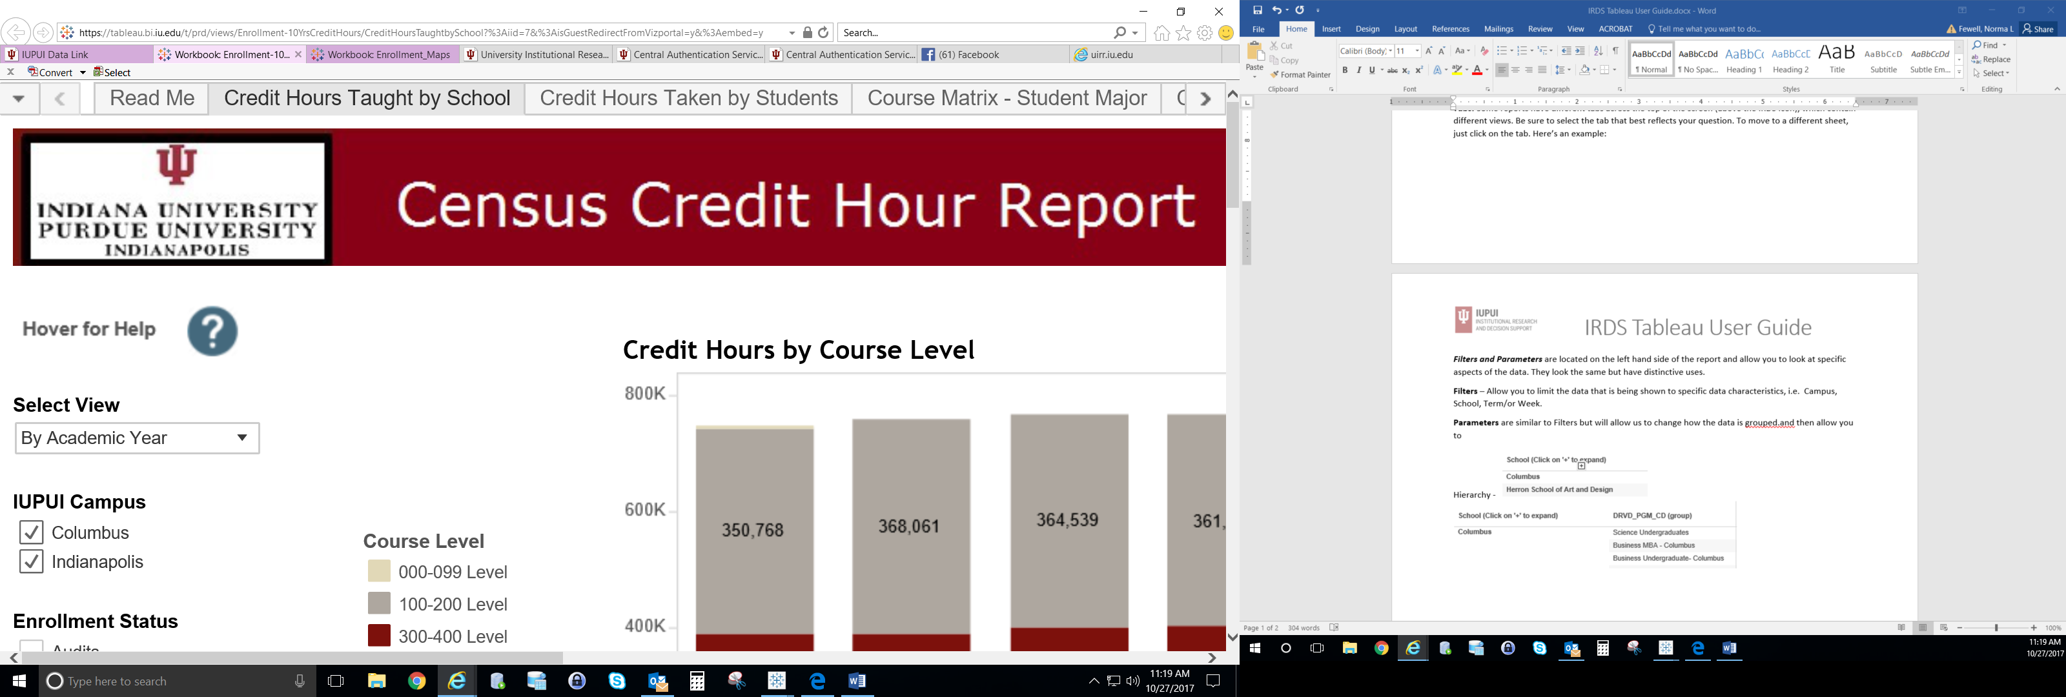

***How to Work with Filters:*** Interactive reports contain filters, which allow a user to customize the report to fil their specific needs. These filters are located on the left hand side of the report and allow a user to drill down into specific data. Once a filter is selected, the graph/or chart will update to reflect a user’s specifications. Filters will not affect the original report and are created for the user’s benefit.

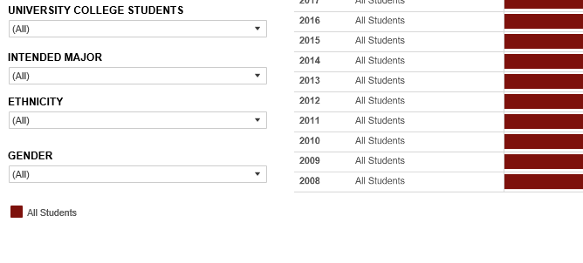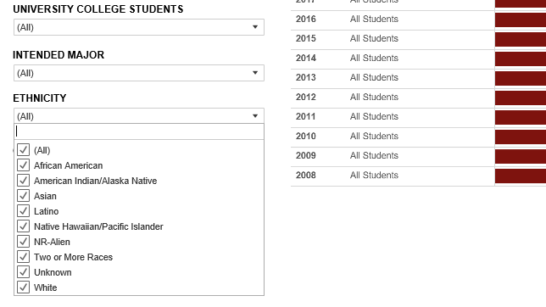

***Step 1:*** *Filters are located on the left margin* ***Step 2:*** *Click on filter triangle to see available options*

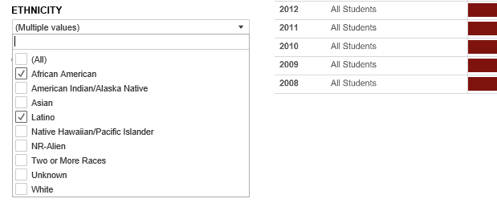 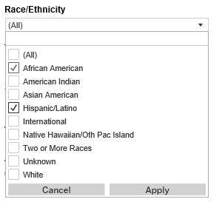

***Step 3:*** *Change the filter to drill down further in the data. Step 4: If an Apply button appears at the bottom of the filter   
Filters also have cream search boxes at the top of bottom of the options, select your filters, then click Apply.  
list of options. Deselect the (All) and then begin typing what you   
are looking for in the box and then press Enter on your keyboard.*

Parameters functions the same as filters but instead of drilling down into the data they will provide a distinctly different view of the data.

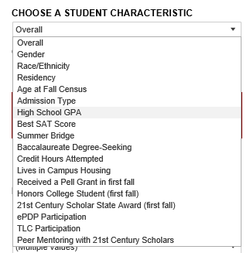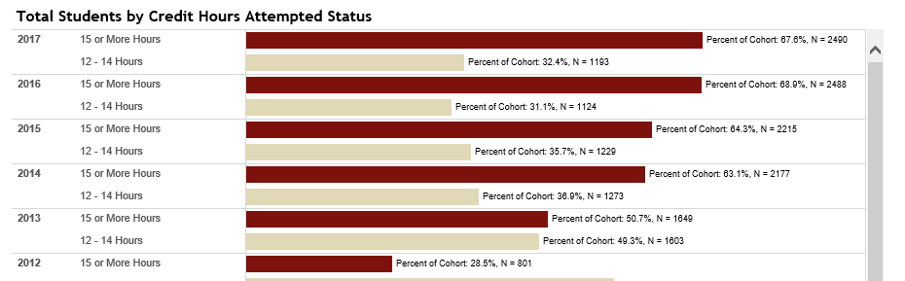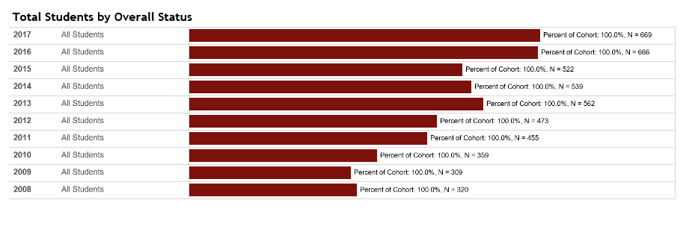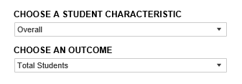

***Tool Tips:*** Hover over **graphs, reference lines**, and **numerical values** to see more details.

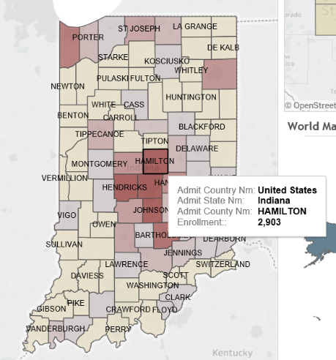

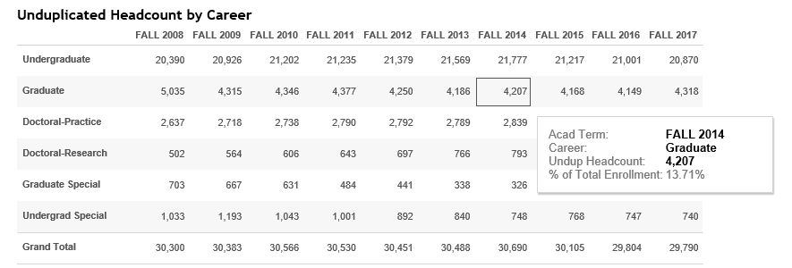

**Highlighting**: When you click on a graph or a legend for a graph, all of the graphical elements that are associated with that data point will be highlighted. To remove the highlighting, click again (sometimes twice) on the same graphical element. In other instances, clicking on an element may act as a filter on an adjacent table or may cause an additional, more detailed report to become visible.

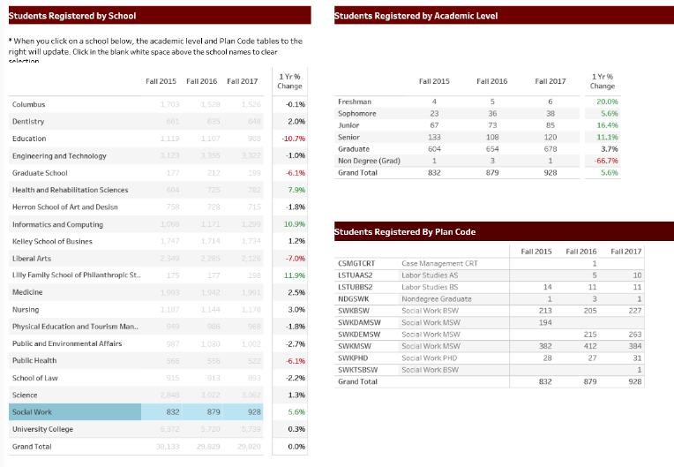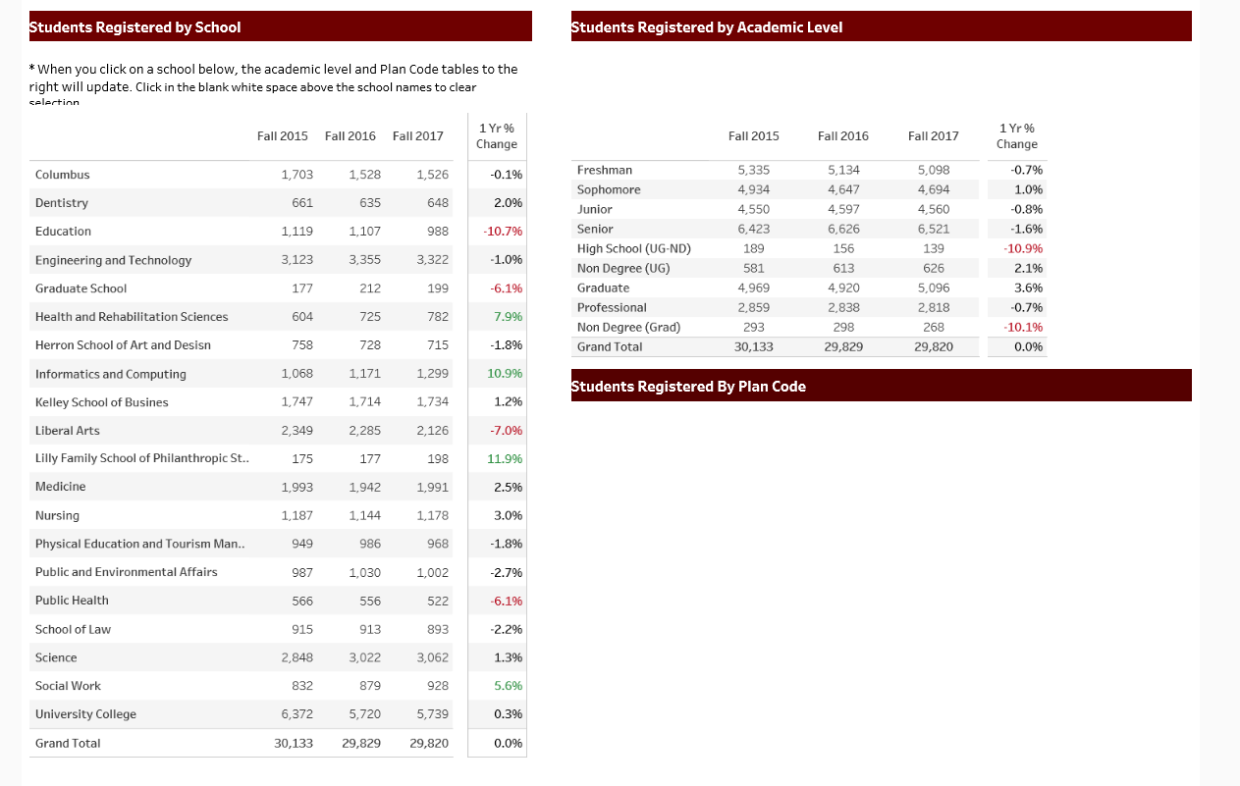

**Hierarchical or Nested Data Views *–*** Hierarchical views allow you to drill down to additional data within a larger category, i.e. School – Program—Plan. This can be done by hovering over a column title until you see a (+) and then clicking on it to expand the data. The reverse is accomplished by clicking on the (-).

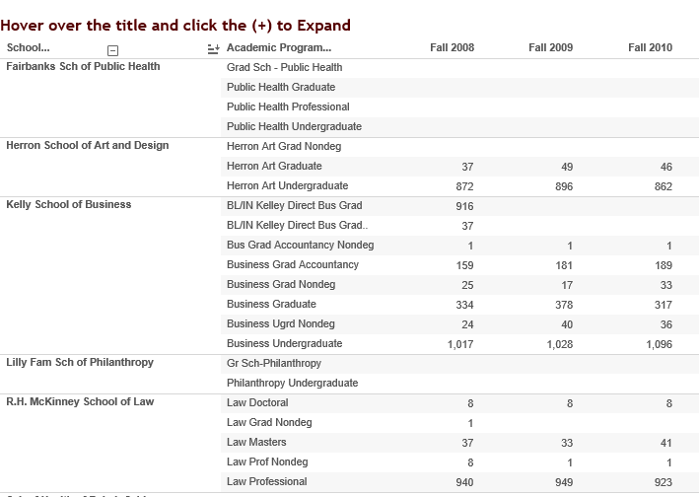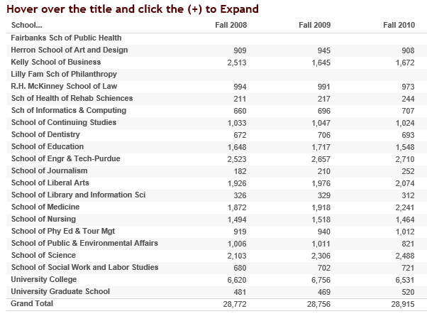

**Other Functions: Tips & Tricks**

For reports that require CAS authentication to access, you will find some additional functionality available.

**BUTTONS:** These are located above or below an interactive report. See below for what   
 they do, and how you can use them:

**Download:** This button allows the user to export the report and its data.

* PDF: A user can download the current dashboard or the entire report as a PDF, allowing you to print what you see.
* Image: This allows a user to save an image of the current graph with the selected filters applied. (You made need to click the report a 2nd time.)
* Data (restricted): The data feeding the report will open in a new window. This data can then be downloaded as a text file.
* Crosstab (restricted): Transfer data from the dashboard into Excel by selecting any of the data from the report.

**Revert:** This button allows the user to clear all filters and view the original report.

**Pause/Resume**: As you interact with a report, you may find the report takes some time to update any changes made with a filter. Use the “Pause” button to pause those changes from occurring as you update the filters. Once you have selected all filters you want, click the “Resume” button to have the report update.

**View:** Once you have applied all the filters you need to see the specific data selection click View and provide it with a name i.e. “Biology”. You will then be provided an opportunity to set this view as you default view. This will allow the report to open to these specific settings each time you login to the report.

**How to Print**

You can quickly print all or part of a workbook using the PDF command on the Download toolbar button. You can select your PDF orientation, paper size, and choose whether to print the entire workbook or selected sheets.

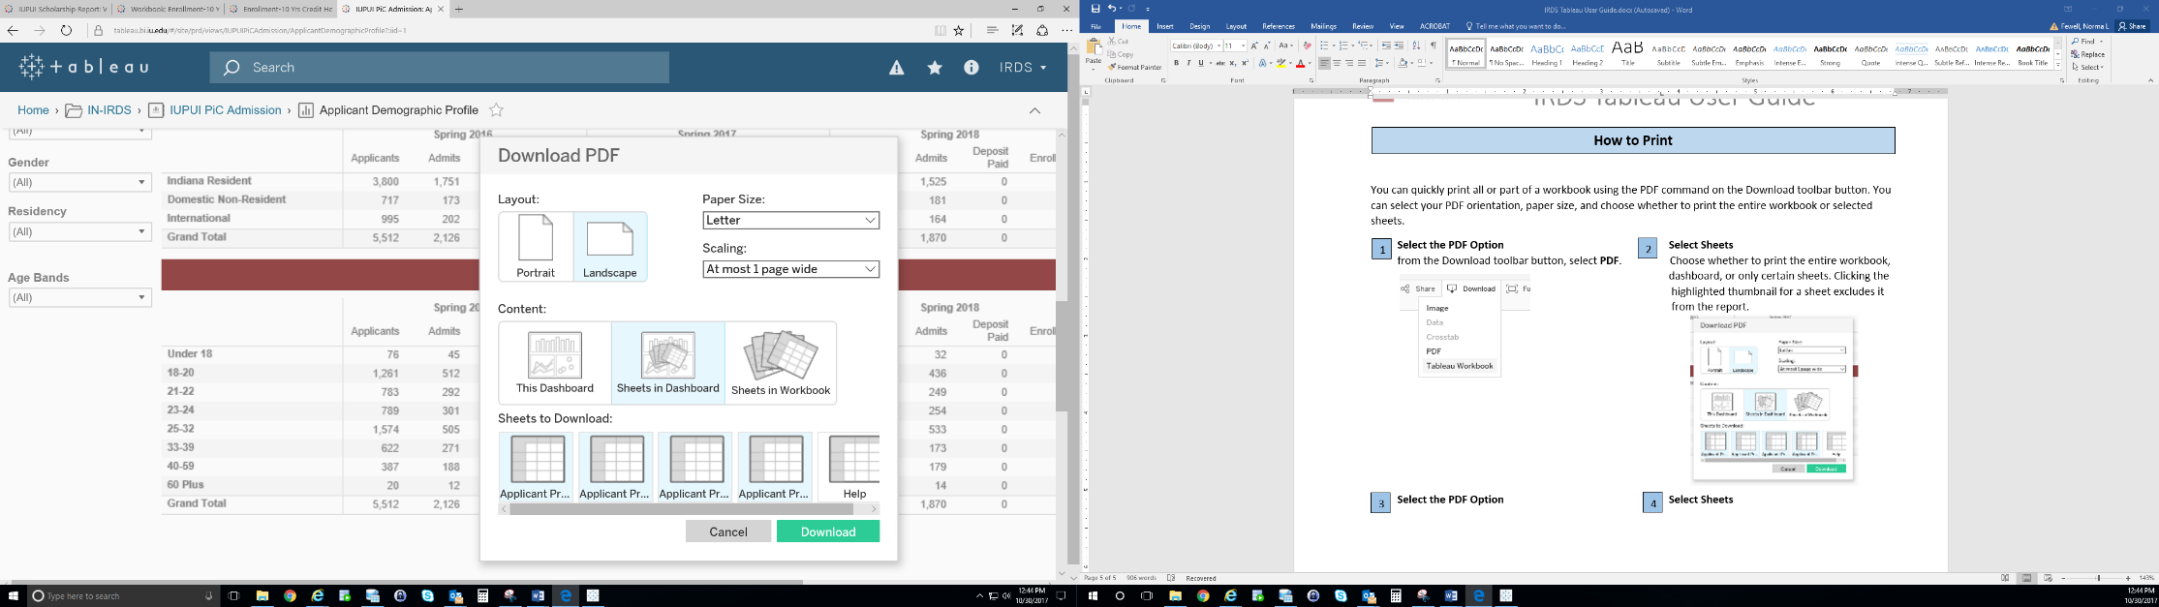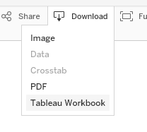 **Select the PDF Option Select Sheets**  
 from the Download toolbar button, select **PDF**. Choose whether to print the entire workbook,   
 dashboard, or only certain sheets. Clicking the   
 highlighted thumbnail for a sheet excludes it   
 from the report.

2

1

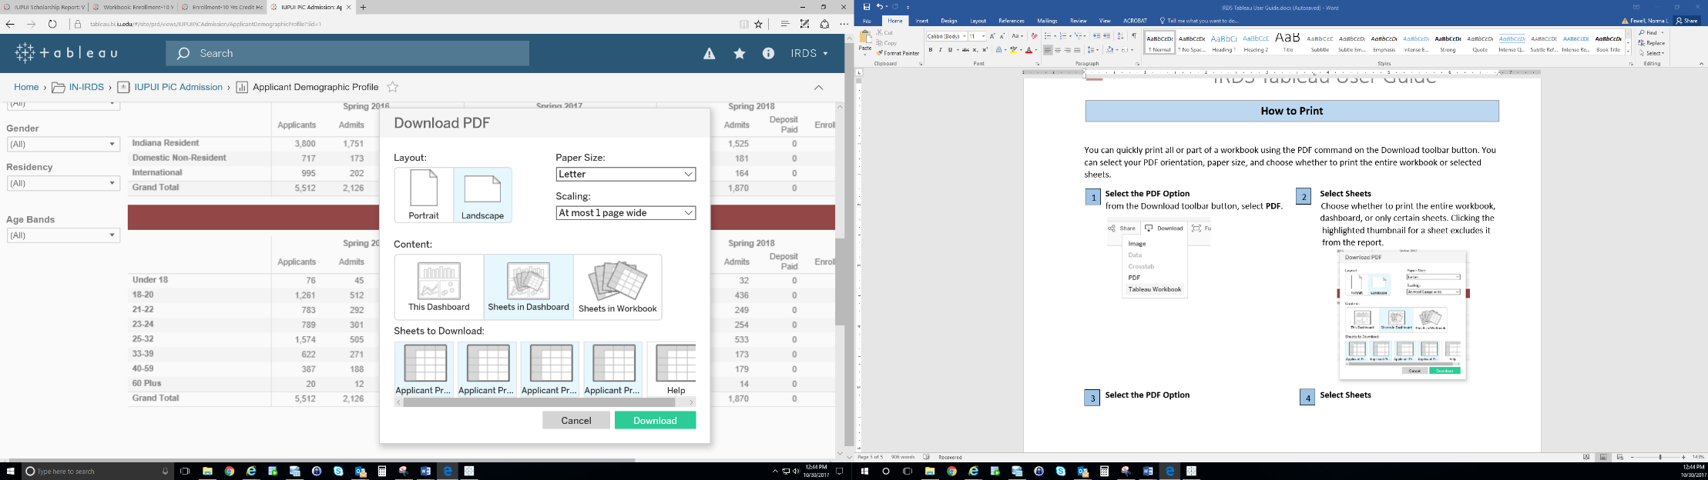 **Choose a Layout and Paper Size Print the PDF** Select either a Portrait or Landscape In the Download PDF dialog box, click download.  
 orientation and a Paper Size. After a few seconds, another Download PDF dialog  
 box will appear. Click download again to download   
 and print your PDF

4

3

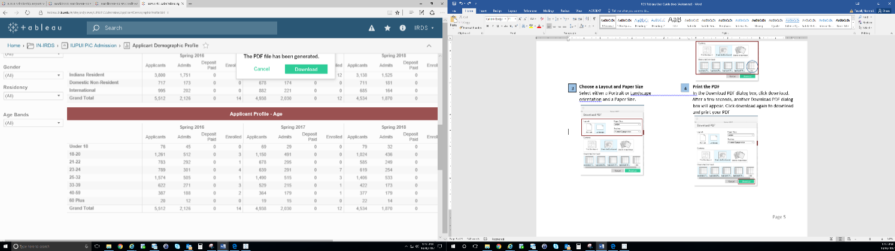

**FAQs: Frequently Asked Questions**

* **Can I “break” a dashboard/alter the data permanently?**

No. The interactive report that is published online is intended for community use. No matter how many filters or changes you make, the original report and data will not be affected.

* **Can I access the data behind the interactive report?**

This depends on the report. If the report is public then the data is not available. For reports requiring CAS authentication the answer is “possibly”. If available, you will use the “Download” button and select “data,” the data will then download into Excel. If you do not see “data” as an option, try selecting data elements within the report first, then click the “Download” button. Many reports will not grant access to data for security purposes, unless you work in a specific IU office.

* **Are there any other Tableau-related resources available?**Yes. [UITS](https://ittraining.iu.edu/tableau/index.html) and [Tableau](https://www.tableau.com/learn/tutorials/on-demand/end-user-training) (requires registering) have websites with training video links and tutorials.

For additional questions, please IE by email: nfewell@iu.edu